Solitaire Settlers of Catan
Written By Steven De Toni (April 2008)

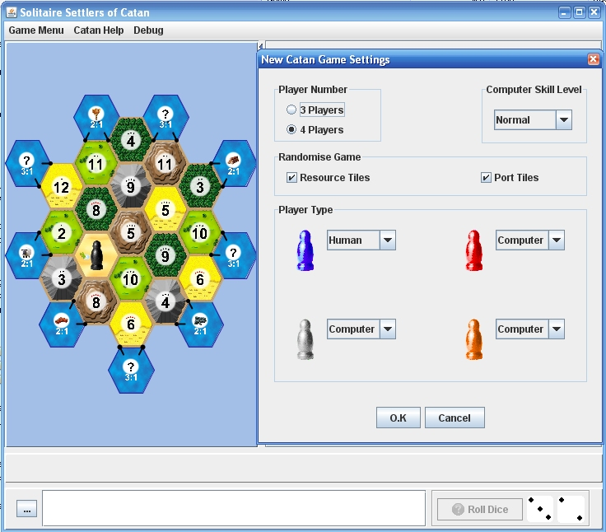

This version of Settlers of Catan allows you to play against AI players (offline) to pass the time away. It’s a free version the plays quickly so a game usually ends in around 10 minutes. To play the game on your computer, it requires Java Runtime Environment 1.5 (JRE 1.5), or a later. Obtain JRE from here http://java.sun.com/javase/downloads/index_jdk5.jsp
The game rules while simple to understand can be a little unusual initially, especially if your used to games like Monopoly. This web site can guide you through the basics, and the computer version will guide you through what you can and can’t so, by the end of a game, you should understand the game fully. If you have never played Settlers of Catan before then give this a try, you may end up liking it. If you do, then please purchase the actual Board Game designed by Klaus Teuber, it’s much more fun playing with friends and family.

Game Turn Sequence
In Solitaire Catan, you control the turn sequence. At each turn a player will have the dice rolled and resources given out. If a 7 is rolled, resources are reduced as needed and the robber is moved. Once at this stage you may build or trade with other players to grain resources. If you are unable to or not wanting to do anything more, you end the turn by clicking the button. If it’s a computer AI’s turn, then you may try trading with that player only or end their turn by clicking the button.

Trading
Trading within the game is very important, without it, the game will have little interaction, and stifles the ability to obtain resources needed to build roads, settlements, purchase development cards, and cities. Solitaire Catan’s trading is only with the computer AI’s, and depending on who’s turn it is, you can sell/buy resources to the current player (not your turn) or to all other players (on your turn). Trading is what slows game play, so to speed things up, Solitaire Catan implements Right Mouse Click processing to end or back track from a trading action. You use the technique to progress through the game more quickly than just clicking the Cancel button. The Right Mouse Click event can occur in any part of a Trading window.
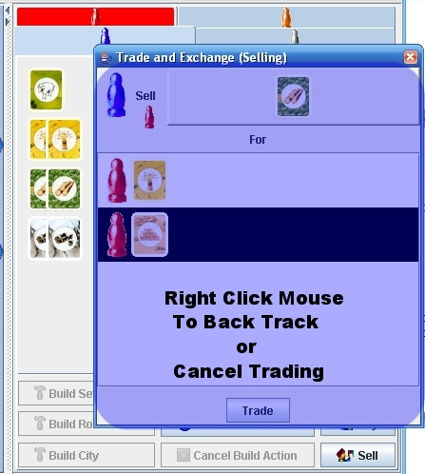

Additional Catan Info
Wiki: http://en.wikipedia.org/wiki/Catan
Board Game Info: http://www.boardgamegeek.com

JRE 1.6 ISSUE
JRE 1.6 runs this game find, but it appears to run it slowly for reasons unknown (Under Windows), thus I recommend JRE 1.5 if running under Windows.

